Alex Loren Woody Peter
Los Angeles, CA
Thursday, February 24th, 2021

VENDOR INFORMATION PACKET

Thank you for joining FutureCon for the Los Angeles, CA CyberSecurity Conference! We are so excited to return to in person events and are happy you are here with us!

Please see hard deadlines we have implemented for 2022

Below you will find the general information needed for the conference, including arrival, set up, attendees, presentation guidelines, and more! I look forward to working with you!

Date: Thursday, February 24th, 2022
Venue: The Hilton LAX
Address: 5711 West Century Boulevard
Set Up Time: 7:00 AM – 8:00 AM PST the morning of event
Conference Time: 8:00 AM – 5:00 PM PST

Please note: Upon arrival, you will go to vendor check-in and pick up your badge and lanyard, you will then be directed to your booth space. A 6 ft table, 2 chairs (double that if you are a Platinum Sponsor), Wi-Fi, and electricity are included in your sponsorship.
Please do not tear down your booth prior to the end of the conference.
Breakdown is immediately after the CISO Panel at approximately. 5:00 pm.

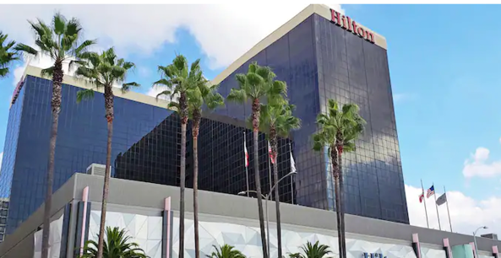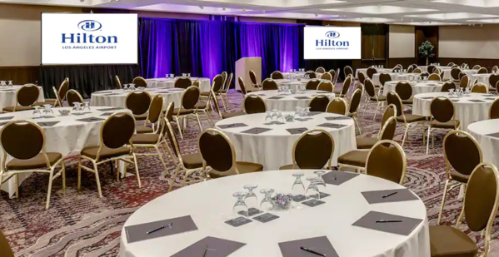
Hilton LAX
Presentation Room

Los Angeles, CA

Sponsorship Resource Center
https://futureconevents.com/la-2022-sponsorship-resource-center/

Virtual Booth & Virtual Event Informational Recording
https://drive.google.com/file/d/1bIiBeRFmk09qYQQV40J8H6284XyPTyMJ/view?usp=sharing

Deliverables
PLEASE MAKE NOTE OF ALL NEW TIMELINES!
Speaker/Presentations …. IMPORTANT INFORMATION…CRUCIAL TO YOUR AGENDA TIME SPOT.
Missing deadlines may default the time of your scheduled presentation.
Turning in your recordings/speaker topics/session titles etc. after the deadline is disruptive to the overall run of the show for FutureCon events.
In 2022 we are implementing firmer guidelines to ensure a seamless production of our events.
If you have a speaker, send Leina@futureconevents.com your speaker’s headshot, bio and email along with the presentation topic, abstract and slide deck.
PLEASE SUBMIT NO LATER THAN FEBRUARY 10TH. This date is two weeks prior to event date, February 24th, 2022.
Failure to comply with deadlines:
- Speaking time slots are filled on a first come basis. (Please note: all session slots are scheduled due to the best interest of the conference. All presentations are subject to approval SEE GUIDELINES).
- If speaking details are not submitted to the FutureCon team prior to the date of the deadline above, your speaking spot is subject to being pushed to the end of the conference.
- AGENDA FINALIZED by February 16th. If we have not received any of the deliverables requested above, your speaking spot time slot is subject to being pushed to the end of the agenda. FutureCon will determine your topic based on our best judgement by going to your company’s website.
Presentation Guidelines
- We strongly encourage your speaker title is not from Sales or Marketing…past analytics clearly prove that the best attended session have speakers from Senior level/C-level technical staff of your company. If you opt to submit a Sales or Marketing staff member your session will more than likely be pushed to the end of the day.
- Must be educational -non-negotiable! Must NOT be a sales or marketing pitch – this is what the exhibit area is utilized for.
- Topics: CyberSecurity is the theme of the conference- examples include Security trends, technical content, real-world examples, case studies, successes and failures, and insights on emerging issues, Best Practices.
- Must follow the Code of Conduct – please be respectful to others and do not disparage other sponsors. Ensure compliance with the stated objectives and avoid overt commercialism.
Presentations should be sent in PowerPoint format (preferred) to flyinhawaiian55@gmail.com and meagan@futureconevents.com, no later than the Fridays prior to the event. Sending PowerPoints ensures that you can access presenter mode during the presentation, allowing you to see your notes.
Drawings and Giveaways
Attendees will be encouraged to visit every booth. If you plan to have a prize giveaway, send me your prize and the value (and a graphic, if you have one). CEO/Host Kim Hakim will be announcing prize winners throughout the event by calling up a sponsor to the stage. You will introduce yourself and pull a winner from attendees that visited your booth. Reps will hold on to the prize as a display for their table.
The giveaway item should not be any product that your company sells. Some examples of past vendor prizes include, gift cards, Amazon electronics, Apple products, Echo, Nintendo, anything fun and unique.
Staff

Please send Leina@futureconevents.com names of your two staff working the event – Please submit names, emails, and titles – Once registered they will receive a confirmation email from the event platform. If you are a Platinum Sponsor, you will have 4 passes!

Additional reps (each booth has 2 chairs) must register through the Sponsorship Resource Center - $50 each additional rep.

A VIP Invite template including your unique promo code will be sent to you.
This is not to be utilize for additional conference staff! Your promo code will be flagged if additional staff is registered with Promo code. Your team will receive an invoice for the additional fees for staff.

We encourage you to share the invite with your sales team that will work the event. Your sales team can invite any prospects they want to get in front of using your promo code for free admission to the event ($200 value). (If you need this invite, please email Leina@futureconevents.com).

Lead Retrieval Process

Attendees’ name badges will have QR codes on them. Reps onsite will simply use their camera (No App required – it is like retrieving a menu at a restaurant) to scan the QR code. It will populate a contact and notes may be added.

The morning of the event, we send out pre-reg lists (not scrubbed) to use as reference. (Note: The list will only be sent if the invoice for the event is paid).

Access to your virtual booth will be sent out 2 weeks prior to the event. Please contact meagan@futureconevents.com if you would like any changes to your virtual booth.

If you have had a virtual booth with us in the past that booth will be duplicated and sent over for and additional updates or changes.
The staff will never be duplicated. Please send the name and email of anyone you would like to staff your booth on a per event basis.

Virtual Booths

- Featured Video: this video is typically 0-5 minutes long and helps introduce the attendee to your company
  - Please send as a YouTube link or file format. You also have the option to upload the file directly to your booth in the media library, please let Meagan know if you have done this so she can add to your booth
- Resources: any files or links you would like to feature in your booth for attendees to see
  - If you are having issues uploading please send these to Meagan and she can help
  - Here is a quick walkthrough of adding resources to your booth: https://drive.google.com/file/d/18o0169HT2rRluBXRxRaUIBo6A2boaWHa/view?usp=sharing
- Background images: If you would like a new graphic for behind your virtual booth please send to Meagan. Sizing 2000x1000. We can also make a graphic for you with your input
- Booth Banner: a banner displayed in the top left of your booth, typically to advertise a prize or speaker. Sizing 275x140. We can also make a graphic for you with your input
- Booth Staff: please send name and email of staff for your booth

Important Note:
*FutureCon LLC is not responsible for any packages shipped to or from the venue. Please make sure your packages are easily identifiable for your representative. This venue may charge for INCOMING & OUTGOING packages. Check the Sponsorship Resource Center for this venue’s specifications on shipping (pricing, whether or not the venue has automatic pick-up from hotel or you have to call in the pick-up).

