Alex Loren Woody Peter
Dallas, TX
Thursday, January 20th, 2021

VENDOR INFORMATION PACKET

Thank you for joining FutureCon for the Dallas, TX CyberSecurity Conference! We are so excited to return to in person events, and are happy you are here with us

Below you will find the general information needed for the conference, including arrival, set up, attendees, presentation guidelines, and more! I look forward to working with you!

Date: Thursday, January 20th, 2021
Venue: The House of Blues
Address: 2200 N Lamar St, Dallas, TX 75202
Set Up Time: 7:00 AM – 8:00 AM CST the morning of event
Conference Time: 8:00 AM – 5:00 PM CST

Please note: Upon arrival, you will go to vendor check-in and pick up your badge and lanyard, you will then be directed to your booth space. A 6 ft table, 2 chairs (double that if you are a Platinum Sponsor), Wi-Fi, and electricity are included in your sponsorship. Please do not tear down your booth prior to the end of the conference.

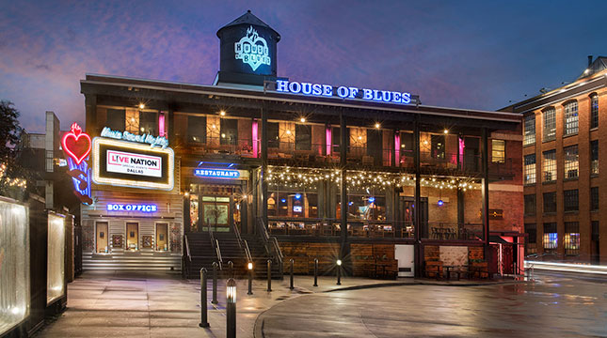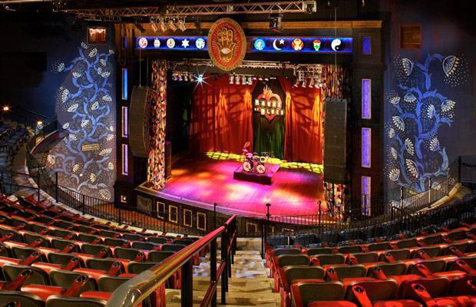
The House of Blues Dallas
Speaker Stage

Dallas, TX

Sponsorship Resource Center
https://futureconevents.com/dallas-2022-sponsorship-resource-center/

DELIVERABLES:
Speaker/Presentations
If you have a speaker, send me your speaker’s headshot, bio and email along with the presentation topic, abstract and slides. We need this information one month prior to the event date to upload to the event agenda on the website. Time slots will be filled on a first come basis, meaning the earlier you sign up for sponsorships, the earlier in the day your presentation will be.
Presentation Guidelines:
- The speaker should not have a sales/marketing title – the higher the title, the better!
- Must be educational
- Must pertain to CyberSecurity
- Must NOT be a sales or marketing pitch – this is what our Exhibitor room is for
- Must follow the Code of Conduct – please be respectful to others and do not disparage sponsors
Presentations should be sent in PowerPoint format (preferred) to leina@futureconevents.com and meagan@futureconevents.com, no later than two Fridays prior to the event. Sending PowerPoints ensures that you can access presenter mode during the presentation, allowing you to see your notes.
Drawings and Giveaways:
Attendees will be encouraged to visit every booth. If you plan to have a prize giveaway, send me your prize and the value (and a graphic, if you have one). CEO/Host Kim Hakim will be announcing prize winners throughout the event by calling up a sponsor to the stage. You will introduce yourself and pull a winner from attendees that visited your booth. Reps will hold on to the prize as a display for their table. Please do not bring any prizes to raffle off at your own booth while at the event!
The giveaway item should not be any product that your company sells. Some examples of past vendor prizes include, gift cards, Amazon electronics, Apple products, Echo, Nintendo, Coffee Makers etc.

Staff:

2 staff working the event – I need their names, emails and titles – once I register them, they will receive a confirmation email.

Additional reps (each booth has 2 chairs) must register through the Sponsorship Resource Center - $50 each additional rep.

We send out a VIP Invite template including your unique promo code. We encourage you to share the invite with your sales team that will work the event. Your sales team can invite any prospects they want to get in front of using your promo code for free admission to the event ($200 value). (If you need this invite again, please let me know).

Lead Retrieval Process:

Attendees’ name badges will have QR codes on them. Reps onsite will simply use their camera (No App required – it is similar to retrieving a menu at a restaurant) to scan the QR code. It will populate a contact and notes may be added.

The morning of the event, we send out pre-reg lists (not scrubbed) to use as reference (something we never did pre-COVID). (Note: The list will only be sent if the invoice for the event is paid).
Important Note:
*FutureCon LLC is not responsible for any packages shipped to or from the venue. Please make sure your packages are easily identifiable for your representative. This venue may charge for INCOMING & OUTGOING packages. Check the Sponsorship Resource Center for this venue’s specifications on shipping (pricing, whether or not the venue has automatic pick-up from hotel or you have to call in the pick-up).

